Nurul Fitri Ansoriyati

**Soal**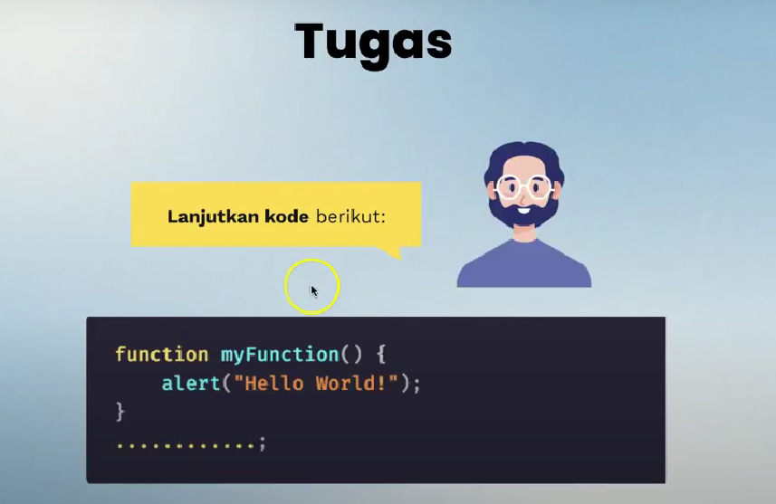

**Jawaban**

